Beer Finder Design Document
Pink Panthers
2012-03-30
1.0 Overview
BeerFinder is a mobile application whose purpose is to allow beer enthusiasts to find a nearby bar which serves their favorite draft beer. Smaller pubs and bars are starting to serve drinks crafted by their local microbreweries alongside the traditional nationwide draft beers. BeerFinder will allow bar patrons to find a bar in an unfamiliar location that serves their favorite beer or serves a style of beer they enjoy, instead of randomly selecting a bar and being disappointed by the beer selection.
2.0 Functionality
2.1 Search
BeerFinder revolves around the robustness identifying the nearest venue that carries a beer which the user is interested in consuming. If the application performs this job poorly, users will stop using BeerFinder.
Users can search for beers using any combination of the following criteria: beer name (Guinness), type of beer (IPA, stout), beer attribute (dark, hoppy), brewer name (Founders, Surly), or venue name (Sally’s, Applebees).
The results of the search should be arranged in the order of the shortest distance and relevance.
2.2 Location
Application functionality depends on accurately knowing where the user is currently located. Location should be gathered in the following order of precedence: GPS, Geolocation by available wifi signals (Google), Cell Tower location, user selection.
2.3 Updating Beer List
Users who are logged in will have the ability to update the beer selection for the venue they are currently located in (within 100 feet). Users who report their location manually are not eligible to update the beer list, as there is no way to verify they are actually at the location.
Users can elect to add new beers to a venue’s list by either selecting from a list (recommended) or by entering their own. For beers that are manually entered, the user can add attributes to describe the beer which would then get used by the search functionality. Beer attributes should primarily be confined to a checklist, instead of freeform entry.
2.4 User Rating & Commenting
All users should be able to read comments, but only logged in users can write comments. Comments are associated only with a venue.
Provide a rating system for comments to prevent “spam” comments from receiving too much attention. The highest rated comments should appear at the top, with all comments rated 1.5 or lower not appearing at all.
3.0 Screen Mock-Ups
1)We have identified five major screens (detailed below) which map out the primary functionality of the application. The screens are: search, list results, map results, venue, and beer details. Once the primary screens are implemented, the peripheral screens can be added: login, read comments, leave comment, and update beer list.
3.1 Search
The first screen the user interacts with is the Search page (or home screen). From here the user can enter a list of search terms and then tap, “Go” to get their results. In addition, the user can tap the “Explore” button is find all registered venues in their location area. Both buttons launch the List Results screen.
In the event the user’s location cannot be automatically determined, they will be prompted to input their location details before the “Go” or “Explore” button loads the next page.
The login button loads a ‘pop-up’ which displays the standard username/ password fields. After logging in, the “Login” button will change to a “Logout” button and their username will be displayed below the Beer Finder label.

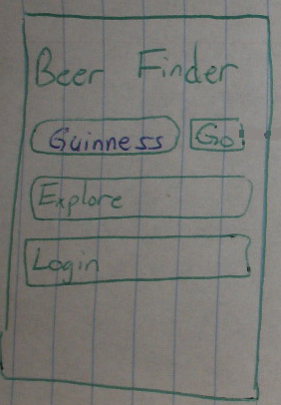
3.2 List Results
The List results screen displays the first 20 results nearest to the user’s location which matches their search criteria. The results will be displayed in a listview, with one result per line. The bottom of the page will have a “More results” button to load the next 20 results. The maximum number of results should be limited to 200 or 30 miles, whichever is smaller.
A button in the top right corner will load the map view display to show a spatially oriented view of the results. Upon tapping on a search result line, the application will load the venue screen.
The Search button will return the user to the Search screen.
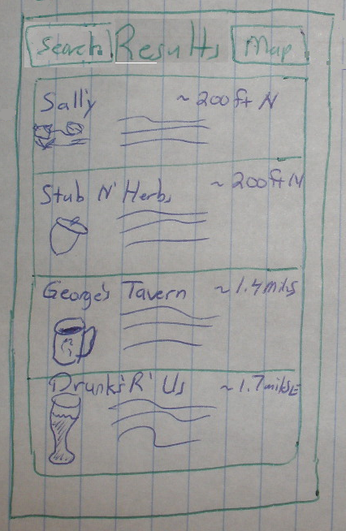
3.3 Map Results
The map view shows the locations of the search results, centered on the user. As the user scrolls around, the application should query the server to automatically load new results. (No limit on distance like the list view has.) Venue locations will be identified using standard destination markers embedded on the map. Upon clicking the marker, the details label on the bottom of the screen will be updated with information for the selected venue. Tapping on the details label will load the venue screen.
The List button will return the user to the List Results screen.
The Search button will return the user to the Search screen.
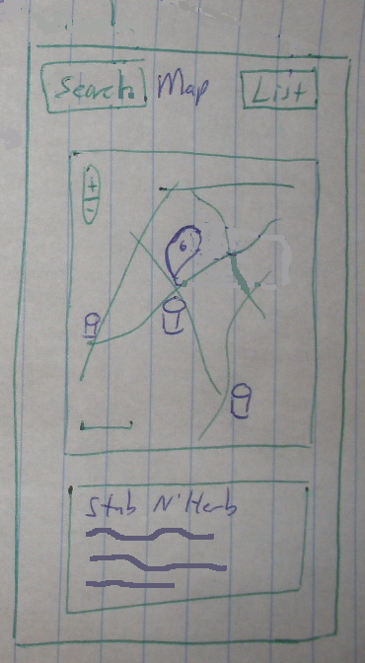
3.4 Venue
The Venue screen provides details about a selected Venue. (A venue could be a restaurant, bar, or concern location.) The details should include the name, address, phone number, and hours of operation. These details could be displayed on a pop-up window that is displayed when the label is clicked, to save screen space.
The most important area on this screen, and the entire application, is the list of beers the venue has on tap. Upon tapping on a list item, that beer will be loaded in the beer details screen.
The bottom of the screen will contain a button to load other user’s comments for this particular venue.
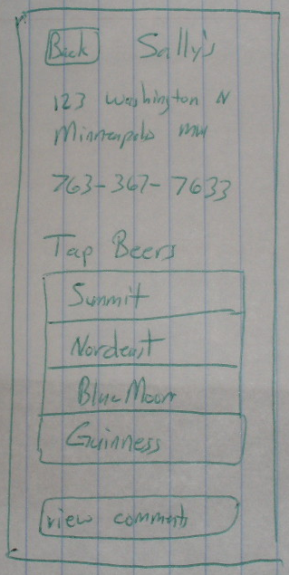..
3.5 Beer Details
The Beer Details screen shows information about the selected beer. This is summarized on an attribute list, ranked by number of full beer mugs out of five. Attributes could contain: darkness or hoppiness. This screen should also contain a short description of the beer and all of the search term it matches with.
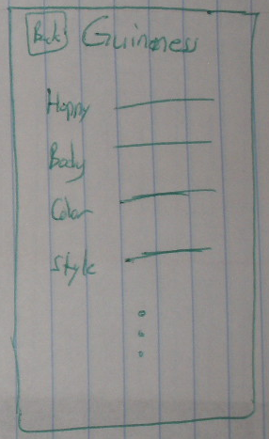
4.0 Architecture
BeerFinder is dependent on a web application which contains all of the beer and venue information. All data that is presented to the user will be retrieved from the web application. The following section details the communication structure between the client and the server.
4.1 Client Server Communications
The mobile application will communicate with the web-application using JSON formatted requests. The responses will contain JSON formatted data. Currently, we are identifying three major messages that must be supported in the first iteration of the application: searching, venue information, and beer information.
Searching: provides a means to perform a search and get back the search results
Client: Search request JSON
{
“id”: “000001”,
“lat”: xx, // latitude of user
“long”: yy, // longitude of user
“result_count”: 25, // number of results to send
“result_start”: 50, // offset into server result list to send (page 2)
“search_string”: terms // user entered search string
}

Server: Search response JSON
{
“lat_center”: xx, // where search was centered
“long_center”: yy, // where search was centered
“search_string”: terms, // terms generating this result list
“count”: a, // number of results
“offset”: b, // how far into results list following results started
result // array of search results
[
{ venue 1 },
{ venue 2 },
{ venue 3 }
]
}

Venue: A method to get information to populate the venue information on both the list result, map result, and venue pages.
Client: Venue request JSON
{
venue_id: id, // identifier for the bar
add // list of beers to remove (usually null)
[
beer1,
beer2
],
remove // list of beers to add (usually null)
[
beer3
]
}
Server: Venue response JSON
{
venue_id: id, // identifier of the bar
result: success/failure/none // result of add/remove action
description: desc, // information about the bar, hours, location, etc.
beers // beers on tap
[
beer 1,
beer 2,
...
]
comments: count, // number of comments for this location
longitude: double, //location of the venue
latitude: double
}

Beer: A method to get all of the data about a single type of beer within the system.
Client: Beer information JSON
{
beer_id: id, // beer identifier
}

Server: Beer information response JSON
{
beer_id: id, // beer identifier
name: beer, // beer name
brewery: brewery_name, // other beer attributes...
hoppiness: hops_rank,
body: body_rank,
color: color_rank,
description: desc,
search: terms
}

4.2 Data Structures
Currently, the only information which will be persisted is the username and password, which will be used to authenticate with the server. All other displayed data will be retrieved from the server every time the application is launched.

5. Design decisions
5.1 Navigation based UI approach vs. tab.
Why we choose navigation over tab?
5.2 Service proxy adapter.
The interaction with the web service will be encapsulated within Proxy Adapter component. For initial implementation service proxy adapter will just mock the web service.
5.3 Displaying search results on the map.
The search results will be displayed on the map as overlay items. (http://developer.android.com/resources/tutorials/views/hello-mapview.html)

